Naama Bejerano

06/07/2024

**Market for Shift Swapping for CS106A/B TA’s**

**Introduction**

At Stanford I work as a teaching assistant for the largest courses at Stanford, the introductory computer science courses CS106A and CS106B. At the beginning of each quarter all of the TA’s (~80 people) submit an ordered list of their preferences regarding which class to teach (A or B), when to teach a weekly section, and when to have a weekly LaIR shift (essentially office hours). A version of the Gale-Shapley algorithm is run to match up stakeholders according to their inputted preferences, in these three categories. Throughout the quarter there is a slack channel titled “swaps” where people regularly post asking for someone to swap a LaIR shift on a given week. For example if I have a regularly scheduled Monday shift, on a given week I may be busy on Monday, I would post in the Slack channel inquiring for a swap to a shift on Tuesday or Wednesday. I would then sit by my phone and anxiously await a response that may never come.

A typical day in the swap Slack channel:



Currently, the process of swapping shifts is slow, tedious, and inefficient. I set out to understand and improve this market with tangible, researched suggestions.

To understand the current market I sent out a form to the teaching assistant community to get their feedback. I used this to collect quantitative and qualitative data reflecting the overall sentiment about the current system and TA’s attitudes towards switching to the automated online system I am proposing. Generally, the reflected sentiment expresses a high rate of dissatisfaction with the current system and support for a new system with reservations about an online system.

To begin improving this market, I read the literature on similar markets and came to the conclusion that a modified version of Top Trading Cycles would work best in this particular case. I adapted an existing Top Trading Cycles implementation for this specific case and ran extensive testing on the algorithm measuring the percentage of people who were successfully swapped, the percentage of people who received their first choice, and the average preference people were assigned to. I ran the same test cases on a Random Algorithm which randomly assigns possible swaps as a comparison point for the algorithm I created and on an algorithm I call the Sequential Algorithm which is meant to mimic how shifts are currently swapped. Finding that the modified top trading cycles algorithm worked significantly better in all areas of measurement.

**Literature Review**

To gain insight into the best algorithm to use to address the market issue at hand, I referred to literature regarding similar situations. The kidney exchange market draws many parallels, treating donors as the agents with “ownership” over the donor they are providing. In this mechanism agents submit a ranked list of preferences over the other donors in terms of compatibility, with cases where multiple donors are potentially compatible and some donors who are not compatible. In this scenario Roth et al. used a modified version of the top trading cycles algorithm to facilitate kidney exchanges. “This is the “housing market" of Lloyd Shapley and Herb (1974), and David Gale's method of top cycles (TTC) produces efficient, core allocations. There is a unique such allocation, and the mechanism that selects it is dominant-strategy incentive-compatible (Roth, 1982).” (Roth, 2004) Beyond this, the key findings included efficiency gains due from using this algorithm facilitating exponentially more life saving surgeries than had occurred without this algorithm in place.

In a completely different market with a remarkably similar core make up, when broken down into key components. Abdulkadiroğlu and Sönmez approached school choice assignment through similar algorithmic methods experimenting with existing mechanisms. They primarily focused on a comparison between the Boston mechanism, Gale-Shapley deferred acceptance, and Top Trading Cycles. The known caveats of each mechanism are that the Boston mechanism is not strategy-proof, neither stable, nor Pareto efficient (however it was the most used in practice as of 2003), Gale-Shapley deferred acceptance is strategy-proof and stable, but not efficient (Roth, 1982a), and Top Trading Cycles is strategyproof, Pareto efficient, but not stable. Each mechanism was tested under different amounts of information available to participants. With key findings that across the board in terms of truthfulness TTC is slightly better than DA and significantly better than the Boston Mechanism, meaning agents are well incentivized to report truthfully to get their optimal outcome. In terms of efficiency TTC is least affected by the amount of information available to agents and that TTC performs as well or better than the other two mechanisms under all conditions. Abdulkadiroğlu and Sönmez ultimately concluded that for the school assignment market the TTC mechanism is superior under the measured conditions.

From here, I further looked into the foundations of the Top Trading mechanism which was used in similar markets and regularly outperforms other popular mechanisms in the different scenarios which were tested, a few of which I elaborated on above. One of the foundational papers on the Top Trading Cycles algorithm, On Cores and Indivisibility, by Shapley and Scarf (1973) details the creation of this mechanism to facilitate “trading of commodities which are inherently indivisible”. This mechanism is designed specifically for a “class of markets in which a consumer never wants more than one item, but has ordinal preferences among the items available” (Shapley, 1973). This description exactly fits the shift swapping market in question, confirming that a variation of Top Trading Cycles is the ideal choice of mechanism for this market.

Top trading cycles algorithm has many benefits in terms of theorems which have been proven throughout the years. Morrill and Roth write in their paper “Top Trading Cycles” published in 2024 which culminates the ongoing research regarding the mechanism. Most notably, TTC ensures that at least one trade gets their first choice, which is not true in the Gale-Shapley deferred acceptance algorithm (Shapley 1973). Additionally, TTC encourages agents to reveal their true preferences as they can not be made better off by misreporting their true preferences (Roth 1982b). TTC is also easy enough to explain and understand to easily inform participants of how they can best participate in the algorithm to maximize their personal gain. Stated by Papai in 2000, “An assignment mechanism is group-strategyproof, Paretooptimal, and reallocation-proof if and only if it is a hierarchical exchange rule”, motivating that for optimal swaps participants must be required to rank their preferences as opposed to leaving space for ambiguity in a non hierarchical exchange. As the paper concludes, “ TTC and its generalizations…will motivate further novel applications in the years to come”(Morrill 2024). From the abundance of literature, it is clear that a generalization of the Top Trading Cycles algorithm is the best mechanism to use to solve the market for shift swapping, which is the motivation for this paper.

**Stakeholder Sentiments**

To be able to better understand the market and stakeholder priorities to create a fitting suggestion to improve the current system I sent out a form to the CS106A/B TA’s. The goal of this form was to understand stakeholders sentiments about the current system, gauge how receptive stakeholders would be to using a clearing house, and understand stakeholders specific reservations about an online clearinghouse system.

When asked about their satisfaction with the current system, they weighed heavily towards strong dissatisfaction.

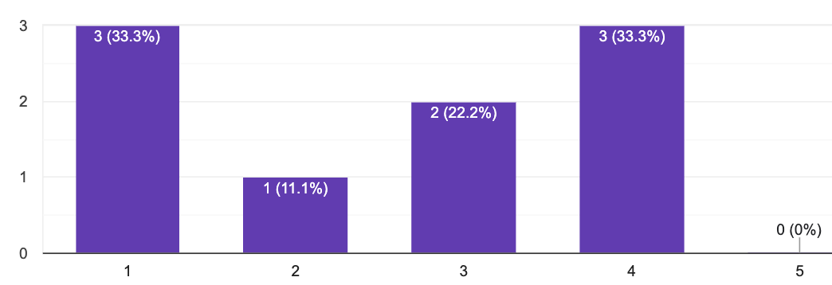

When asked if they would prefer an automatic system as opposed to the current system, sentiment was overwhelmingly positive

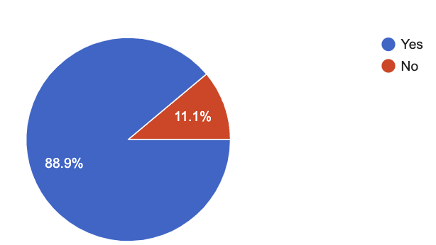

Stakeholders expressed a general preference for receiving a more preferred swap as opposed to receiving a swap sooner.

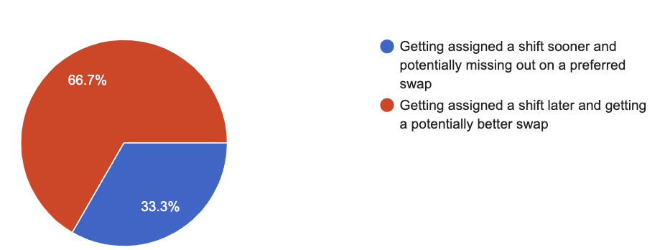

Stakeholders expressed their specification reservations regarding a clearinghouse system.

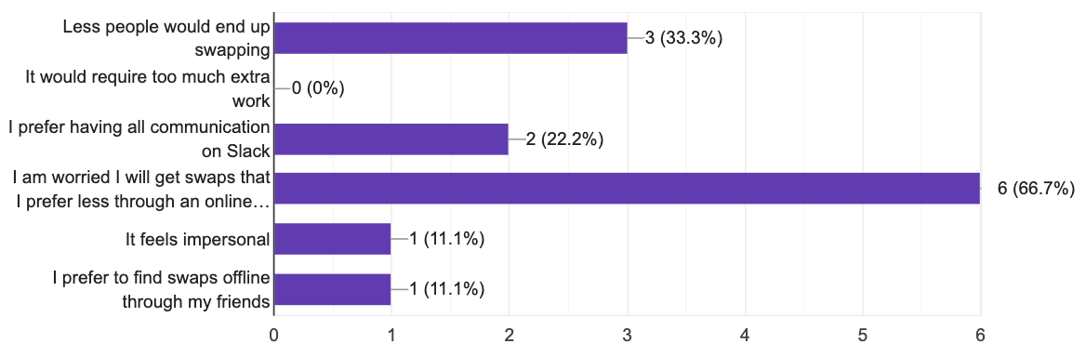

Overall these findings are helpful in informing decisions regarding algorithmic design choice to address stakeholder concerns and preferences. Additionally, this information demonstrates a general willingness to switch to a different system than the one that currently exists and shows that stakeholders would be receptive to an alternative suggestion, as the one I detail in this paper.

**Simulation and Quantitative Findings**

1. **Technicalities in the Market**

To model the scenario of shift swapping among TA’s the larger market must first be broken down into its technical parts. There are ten possible shift assignments ranging from Sunday until Thursday with an early or late option on each day. The shift assignment is assigned at the beginning of the quarter and remains constant throughout the quarter. This mechanism is designed for temporary shift swapping for one particular week. The TA’s in this case are modeled as the agents and the shifts are modeled as the houses, going off of the original example used to explain Top Trading Cycles to assign houses. TA’s “own” the regular shift they are assigned and they submit a ranked list of their preferences of which swap to shift with for that given week.

1. **Suggested Algorithm - Modified TTC**

Following a deep dive into the literature and breaking up the market at hand into its component parts, one algorithm reigns superior: Top Trading Cycles. Using a github repository for a generic version of Top Trading Cycles, I modified the code to fit this specific situation. Some of the adjustments made included changing the inputs to the algorithm to represent the 10 potential shifts an agent can have ownership and allowing multiple agents to have ownership over the same shift. To handle the case where there exists more than one person with ownership over a specific shift, let's say Sunday late shift, if a different agent’s first choice preference is the Sunday late shift they will point to one of the Sunday late shifts available at random to break the tie. If in that round of top trading cycles the agent who prefers a Sunday late shift is not matched, their first choice in the next round is still a Sunday late shift and they will point to a different Sunday late shift. According to the literature on Top Trading Cycles, ties of this kind can be broken randomly without affecting the integrity of the algorithm. Another adjustment I integrated was to keep the agents valid preferences, meaning only including the subset of their preference list which exists in the “market”. Additionally, if any agent is unable to be matched up for a swap they are ultimately removed from the graph and the respective shift they have ownership over is removed as well. Further smaller changes were made to the existing algorithm to make it possible to accommodate this specific market scenario.

1. **Modeling the Swap Slack Channel- Sequential Algorithm**

Regardless of the evaluation metrics used an algorithm is only as good as its alternatives. In order to better evaluate how well my proposed algorithm works I created a simple algorithm which attempts to mimic how swaps are currently implemented, the Sequential Algorithm. This algorithm has a significant amount of caveats in terms of how well it mimics the current situation which are explained in depth in the discussion portion. In the Sequential Algorithm each agent is processed one at a time, the current agent is compared to the rest of the agents which have already been processed and if there is a possible direct swap it is immediately executed. A possible swap means that agent 1 owns a shift that agent 2 has in their list of preferences and vice versa. Once the swap is executed both agents are removed from the map of options for future agents to swap with. This attempts to mimic the current system as best as possible and serves as a useful control basis for this experiment.

1. **Control Algorithm - Random Algorithm**

To be able to compare my proposed algorithm to a different generic algorithm which would complete swaps I wrote the “Random Algorithm”. This algorithm is meant to serve as a control showing how an unsophisticated centralized clearinghouse could work. The algorithm iterates once for each agent in the market, in each iteration two agents are selected at random. For the randomly selected agents if they have a compatible switch, meaning the shift agent 1 owns is in agent 2’s listed preference and vice versa, then they are swapped. Once all iterations are completed the agents which have not been successfully swapped are marked as such and the end results are returned.

1. **Evaluation Metrics**

In order to evaluate the different algorithms I utilized three objective measures which I had observed were used in other research papers to evaluate matching algorithms. The measures are the percentage of agents receiving their top choice, percentage of agents matched, and average preference rank of matched agents. I utilized these quantitative units of measurement to evaluate the performance of the algorithms in comparison to one another.

1. **Test Cases**

To thoroughly evaluate the models I worked with a variety of test cases to see how the algorithms responded under different types of input to be able to fully evaluate how well they work relative to one another, and in general. For each test case I decided what to test and create the test cases with the help of Chat-GPT to generate them. The first test is with five agents who each own different shifts and have preferences over all shifts, other than the one they initially own. Second, is with ten agents where each shift is owned by exactly one person and each agent has a preference list of length four. Third, twenty agents with two people owning each shift and preference lists of size two. Fourth, twenty agents with two people owning each shift and preference lists of size eight. Fifth, sixteen agents with one shift owned by five agents and one owned by two with all others with one owner, preference lists of size three. These tests are meant to test different aspects of the algorithms to see how they prefer with variable amounts of agents, congestion in terms of initial ownership, and how they are affected by the amount of preferences listed.

1. **Quantitative Results**

Statistics split up by test case:

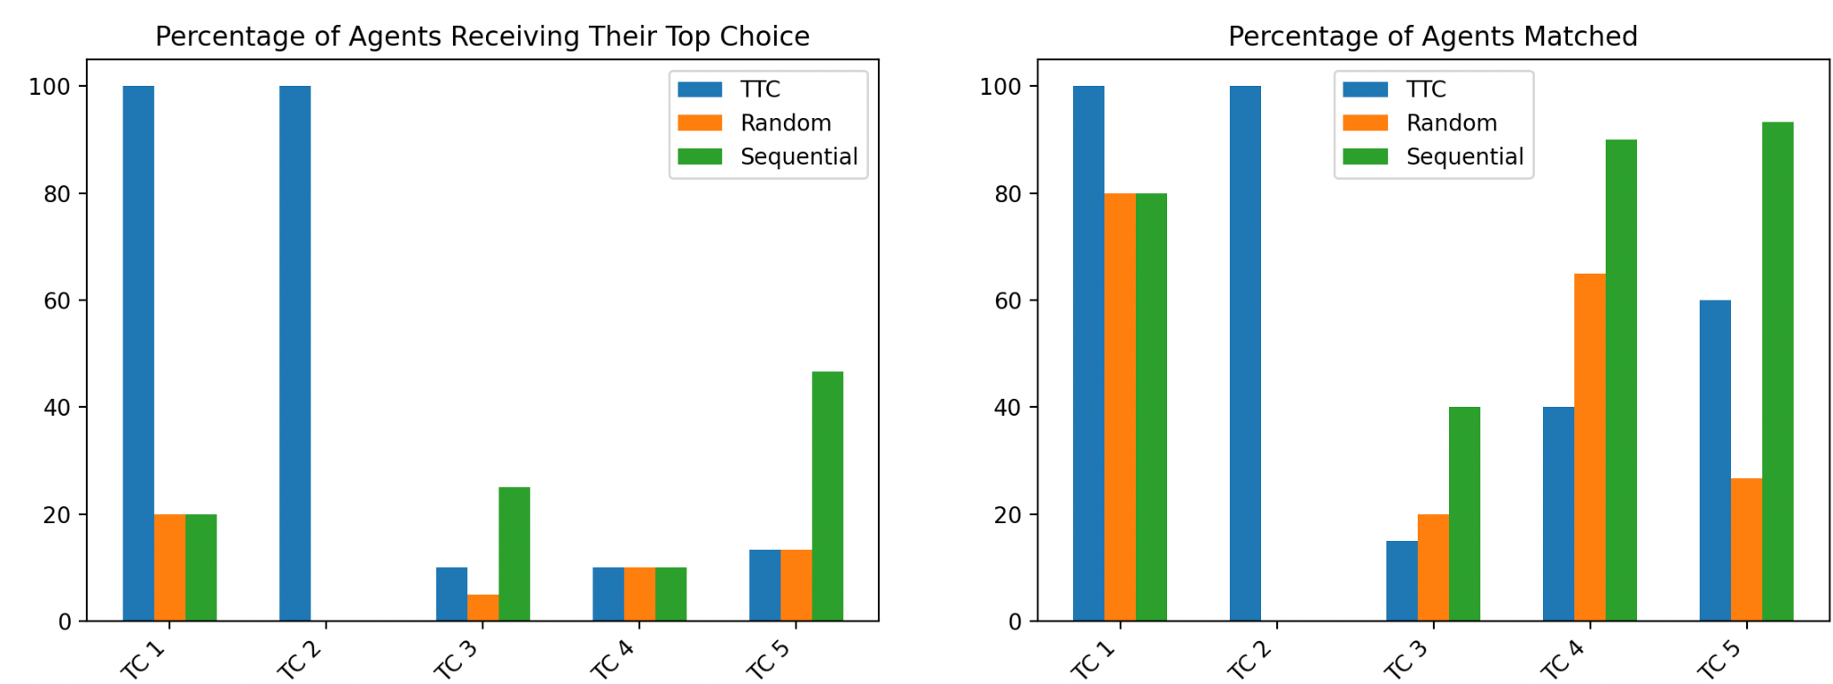

Overall Statistics Averaged from the 5 test cases:

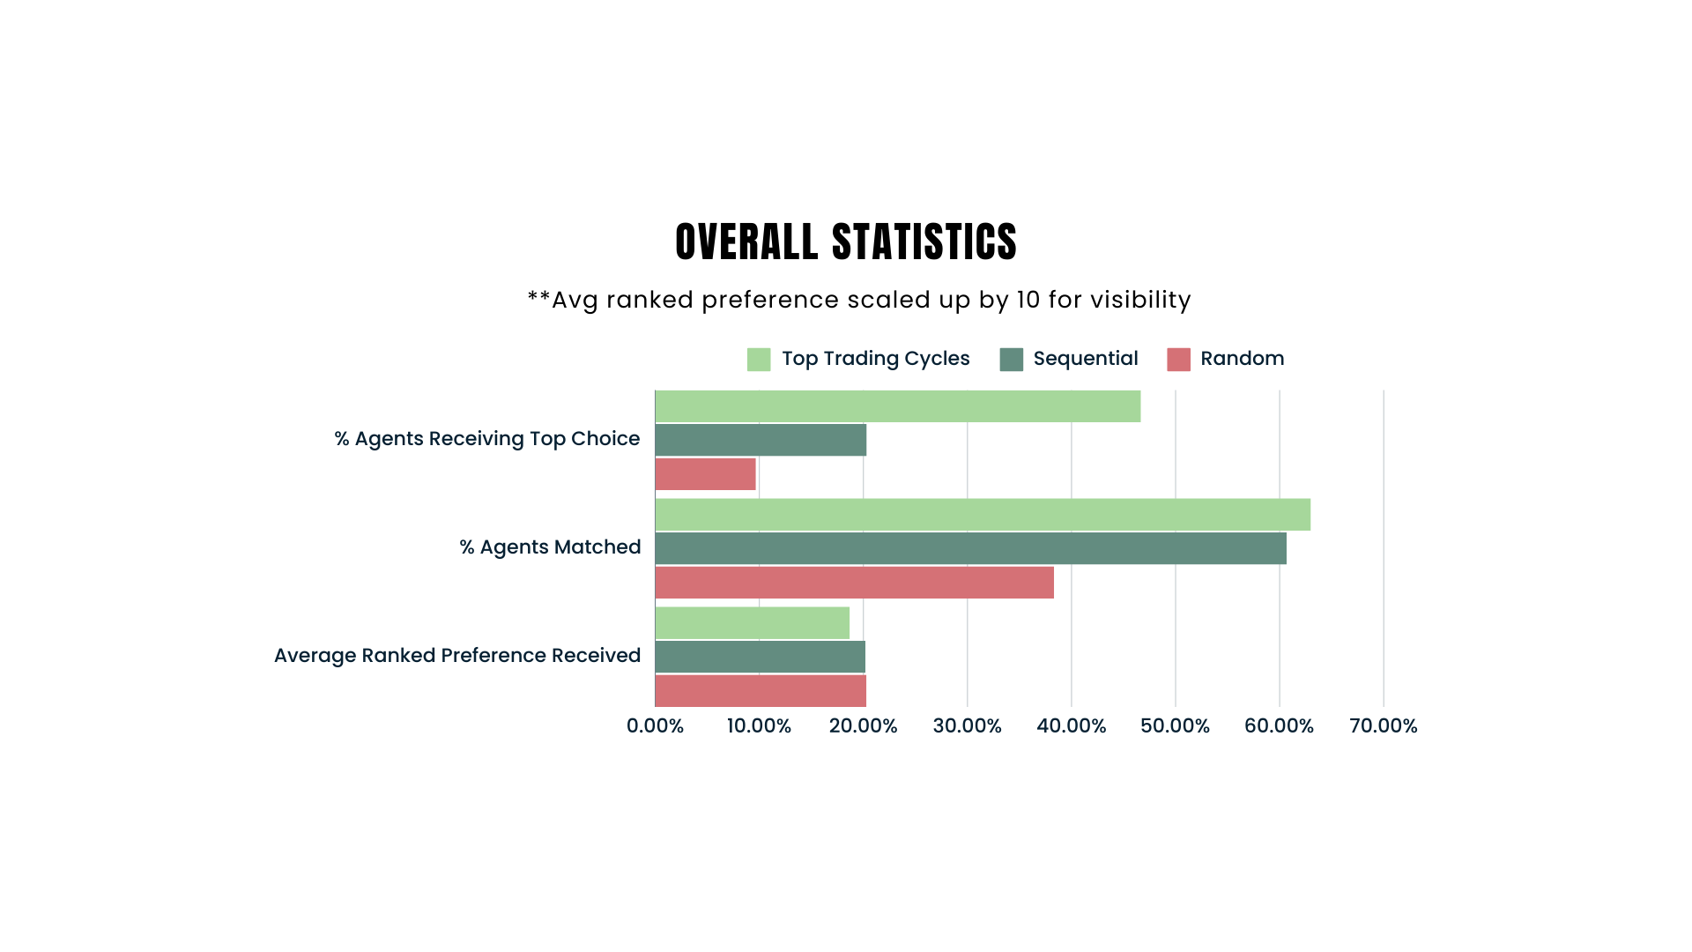

|  | % Agents Receiving Top Choice | % Agents Matched | Avg Ranked Preference Received |
| --- | --- | --- | --- |
| TTC | 46.67% | 63.0% | 1.87 |
| Sequential | 20.33% | 60.67% | 2.02 |
| Random | 9.67% | 38.33% | 2.03 |

**Analysis**

1. **Quantitative Results Analysis**

In the first tables, with statistics separated by test case, it is clear to see that there is a high amount of variation between the test cases, meaning that how well the algorithms work relative to each other is highly dependent on the specific scenario. As expected, Top Trading Cycles works significantly better when there are cycles and a limited amount of preferences listed. The Random Algorithm consistently underperforms in comparison to the other two algorithms, which makes sense since this algorithm is used as a baseline example of how an unsophisticated clearinghouse would work. In comparing the performance of Top Trading Cycles as opposed to the Sequential Algorithm one is not always better than the other. In terms of percentage of agents receiving their top choice, TTC outperforms overall, but with variation depending on the specific test case. The percentage of agents matched is overall higher in TTC, but is more comparable to the Sequential Algorithm. From the overall statistics, TTC performs better than the two alternative algorithms in the three measured regards with the Sequential Algorithm as a close second, and finally the Random Algorithm in a further third place.

1. **Further Improvements to Quantitative Analysis**

While the above analysis provides useful insight into the performance of each algorithm, with more time a more in depth and informative analysis could be conducted in the future. The most important part to understand is when the Top Trading Cycles algorithm outperforms the Sequential algorithm and vice versa. This would be done by drawing out very specific, well thought out, test cases with repeated testing on a variety of specific inputs where each test case has a designated purpose. The test cases I designed and implemented are a good starting point, significantly more can and should be done in this area to reach more meaningful conclusions. These findings should be utilized to further improve the Top Trading Cycles algorithm as testing will reveal its specific weaknesses which can then be addressed.

**Discussion**

1. **Shortfalls of Mimicking Current Behavior**

In an attempt to mimic the current behavior which occurs in the Slack channel used for facilitating swaps I created the Sequential Algorithm. However, this algorithm does not fully encapsulate the real world scenario. This algorithm assumes that the same amount of people who currently use the Slack channel would use the automated system. However, I expect more people to use the automated system since there is no longer a spam risk, in which you want to avoid asking too often in the public channel and you can easily detail your preferences exactly as they are. For example, I currently hold a Sunday late shift, I would always prefer to switch to a Monday early shift, however I do not want to constantly send messages in the group and rarely request this swap since it is a preference as opposed to a need. Additionally, with the current Slack channel the issues of messages getting lost depending on when they are sent is not reflected in the algorithm. Beyond this, the current system offers an implicit limitation in which people do not initially disclose all of their preferences. Stakeholders prefer to get one of their top choices and will initially request a swap with a limited number of alternatives and if they need the swap and do not receive one only then will they disclose their full preferences in hopes of finding any match. In general, the Sequential Algorithm which is written and implemented to represent the current situation is an idealized version of how the Slack channel currently works from an algorithmic perspective. The performance of the current system underperforms in all measured aspects as opposed to the Sequential Algorithm, further extenuating the findings which reflect that the proposed Top Trading Cycle overperforms in comparison to the Sequential Algorithm.

1. **Benefits and Drawbacks of TTC**

As mentioned in the literature review, no algorithm is perfect and each has their own sets of benefits and drawbacks. Top Trading Cycles is individually rational, strategyproof, and pareto optimal however it is not necessarily stable. In weighing the pros and cons of each algorithm, TTC remains the best choice, although there is cause for some concern considering the result of TTC is not necessarily stable. This means that there could potentially be market unraveling if people create a blocking pair. However, I would assume this would not regularly be an issue since it would take a lot of work from participants to realize they are in a blocking pair. The hope is that if people are getting matches they are generally happy with and they are satisfied with the performance of the algorithm they will not search for alternatives decreasing the risk of blocking pairs.

1. **Vision for Implementation of a Clearinghouse**

For an automated clearinghouse to work well in reality the details of the entire process from TA’s submitting preferences to receiving swaps is critical. My preliminary suggestion on implementing this mechanism is having an online website where TA’s can submit their requested swaps for the week with the swap they have ownership over and their ranked list of preferences. The mechanism would primarily on Saturday, to assign swaps for the upcoming week, to be able to achieve high market thickness and urge TA’s to submit their swap requests before the upcoming week. However, often there are requests for last minute swaps, these will still be accepted and the algorithm will run a second time on Tuesday morning to allow for flexibility. The Tuesday reassignment is expected to have decreased performance since there will be significantly less agents in the mechanism at this time. Once the algorithm has run stakeholders will receive an email with details of their swap if assigned, the stakeholders then need to confirm that they accept the swap they received. If they reject the assigned swap both agents are placed back into the mechanism to potentially be rematched in the secondary run of the mechanism on Tuesday. All TA’s that are not matched after the Saturday run of the algorithm will have their information posted on a page for all teaching assistants to see to encourage TA’s to make swaps they were not originally intending to to help out a fellow TA. Until this mechanism is actually run in practice it will be difficult to truly know how well it works and will need to be monitored and adjusted carefully in the beginning stages as more data about TA’s preferences are gathered through use of the online clearinghouse.

Ultimately the success of this new mechanism is built on how an online clearinghouse is explained and perceived by stakeholders. The algorithm must be easy to use, have convincing thorough evidence of its improved performance from the current mechanism, and provide results TA’s are happy with.

**Conclusions**

While this paper is only the very beginning to address the failures in the market for shift swapping between computer science TA’s at Stanford University, the findings and suggestions point in a positive direction towards improving the current state of the market. An overwhelming number of TA’s reported they would prefer an automatic online system as opposed to the current Slack channel. Ultimately, this is one of the most important details as it reflects stakeholders' willingness to change from the current system making space for a new and improved system. Additionally, stakeholders express their top priority is receiving the best possible swap, meaning getting a shift that is higher ranked in their list of preferences. Stakeholders' main concern regarding an automated system versus the current system, is that they would receive a less preferred swap through an automated system. These two main ideas served as the cornerstone in designing an automated system, with priority to assigning stakeholders to a high ranked preference.

The findings in the quantitative analysis of the Top Trading Cycles algorithm as opposed to the Random algorithm and Sequential Algorithm are consistent with these goals. The TTC algorithm outperforms both other algorithms significantly by making swaps which are more preferred for TA’s. While additional testing and modification should be done to explore what particular situations TTC works best in, the preliminary results are promising. The proposed algorithm works better than the current mechanism and addresses stakeholders' reservations about an automated system.

Overall, the suggested algorithm which is a modification of the Top Trading Cycles algorithm works better than the current alternative and has the potential to heavily improve the current system. A centralized clearinghouse with the use of the suggested algorithm would encourage more swaps, result in better swaps, and encourage people to opt in as the mechanism is strategyproof and Pareto optimal. An implementation of an online clearing house would aim to simplify the work needed to be done by teaching assistants to swap shifts and provide teaching assistants with peace of mind that they are receiving the best possible swap.

**Acknowledgment**

Suggestions and conversation from these people have helped inform the suggested mechanism and paper as a whole:

* Paul Milgrom, Stanford University, Professor of Economics
* Aviad Rubenstein, Stanford University, Professor of Computer Science
* Eric Budish, University of Chicago, Booth School of Business

**Bibliography**

Morrill, Thayer, and Alvin E. Roth. “Top trading cycles.” *Journal of Mathematical Economics*, vol. 112, June 2024, p. 102984, https://doi.org/10.1016/j.jmateco.2024.102984.

Pais, Joana, and Ágnes Pintér. “School choice and information: An experimental study on matching mechanisms.” *Games and Economic Behavior*, vol. 64, no. 1, Sept. 2008, pp. 303–328, https://doi.org/10.1016/j.geb.2008.01.008.

Roth, Alvin E, et al. “A Kidney Exchange Clearinghouse in New England.” *American Economic Review*, vol. 95, no. 2, 1 Apr. 2005, pp. 376–380, https://doi.org/10.1257/000282805774669989.

Sanjayvr. “Sanjayvr/Top_trading_cycle: This Is a Python Implementation for Top Trading Cycle Algorithm Which Is Used for Matching.” *GitHub*, github.com/sanjayvr/Top_Trading_Cycle/tree/master. Accessed 7 June 2024.

Shapley, Lloyd, and Herbert Scarf. “On cores and indivisibility.” *Journal of Mathematical Economics*, vol. 1, no. 1, Mar. 1974, pp. 23–37, https://doi.org/10.1016/0304-4068(74)90033-0.

*Chatgpt*, chat.openai.com/. Accessed 7 June 2024.